pY2Q1W1

Saul & the witch

Hold up: the road signs.

Ask: What do they tell us?
Ask: What would happen if someone removed them or switched them around?
Hand out: The road signs to colour in.
Say: Today's story is about someone who didn't listen to God's warnings.

Bible Story

Ask: Who did the witch say she was talking to?
Ask: Who was she really talking to?
Say: When Saul had stopped listening to God, God had chosen a new man to be king. He wasn't king yet, but he knew that one day he would be the king. Do you remember his name? – We learnt about him last week.

Sing songs

Say: Every week this term we will be making a page to add to a scrapbook. We will have a photo, a "who & what" card and a verse as well as some decorations for each page.

Return to tables
Memory Verse: Fill in the blanks and then say the memory verse on the colouring page.

Craft:
- Choose a coloured cardboard
- Add the black squares, photo, who/what and verse cards (there is already double sided tape on them) (Older children may like to put cardboard borders behind their photos etc)
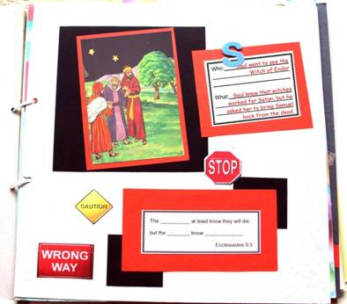
- Add the road sign stickers
- Add a foam letter.
- Fill in the blanks in the verse.

Discuss the following depending on age, interest and time:
Does Satan still try and trick people in the same way today?
Do people still try to talk to dead people?
What are some TV shows with "dead people"?
Should we watch TV shows with "dead people" or witches?
What does the Bible say happens when we die? (See Bible Text sheet)
How can we know if something (like a miracle) is from Satan or from God?

Ask: When people say they are talking to dead people, who are they really talking to? (Satan or his angels)
Ask: Should we talk to Satan? Can we trust what Satan tells us?
Say: Satan wants bad things to happen. Sometimes he will try and trick us by making something seem good, but we will find out later that it is really bad. We must ask God to help us see Satan's tricks.

Finish with prayer at each table.

